**Create 4 Vpc's in 4 different regions and setup transit gateway.**

**--Create vpc in different regions by changing the regions “(choose diff CIDR range for each vpc)”**

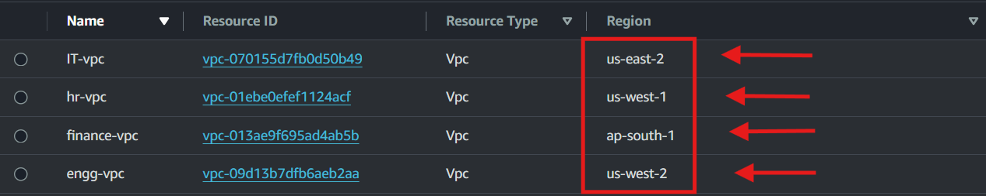

>>Once vpc is created then add 2 subnets to each vpc with one private and one public

**--Create internet gateway and attach it to the each vpc**

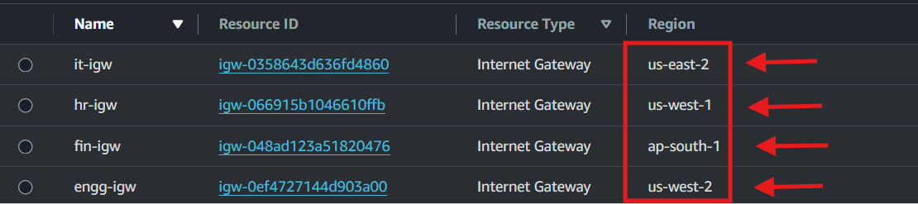

>Go to transit gateway section and create 1 transit gateway for each region and note down the transit gateway ID

>Create transit gateway attachment and choose the TGW created for region and choose vpc and add the vpc created for the region u are in.

>Create another transit gateway attachment and choose “peering connection” this time and select the another region and add the TGW ID for that region.

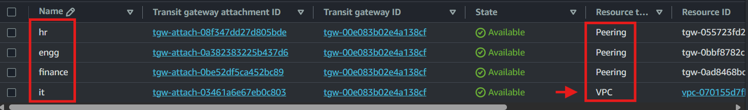

***“REPEAT THIS PROCESS FOR ALL OTHER 3 REGIONS”***

**>>Go to transit gateway route table and select the route with your igw-id > choose routes > create static routes**

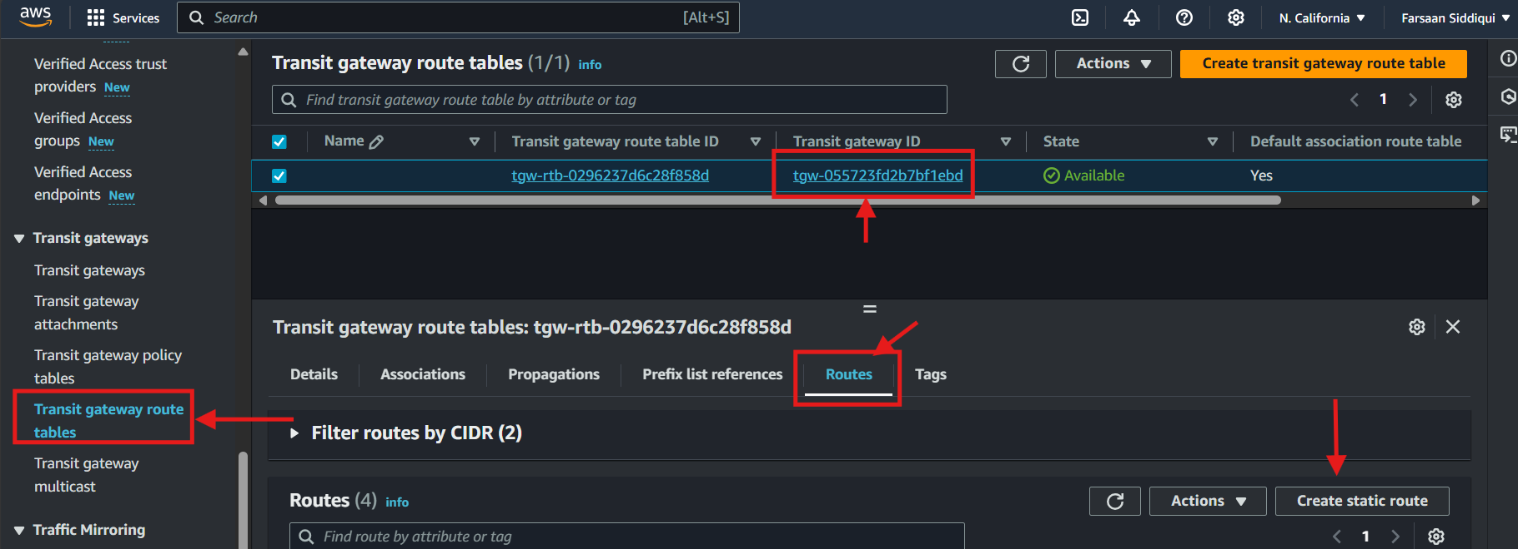

**--ADD CIDR FOR VPC’s CREATED IN DIFFERENT REGIONS AND MAKE SURE TO SELECT CORRECT TGW attachment**

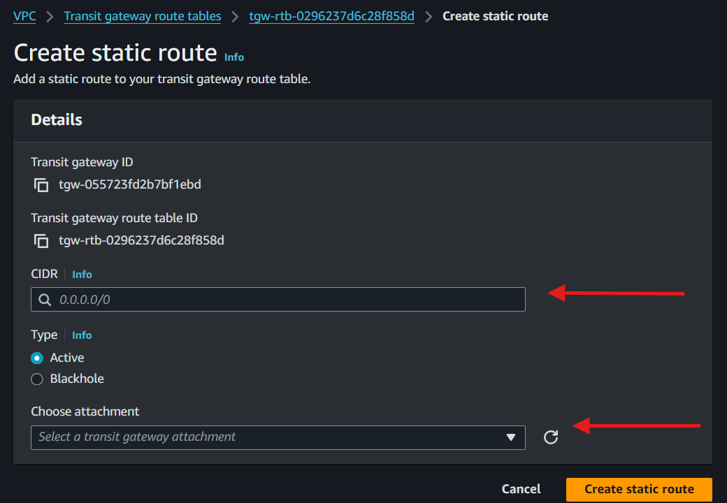

**“REPEAT THIS WITH ALL THE REGIONS”**

**>>GO to route table of your vpc and and select the routing table for vpc created and click edit routes**

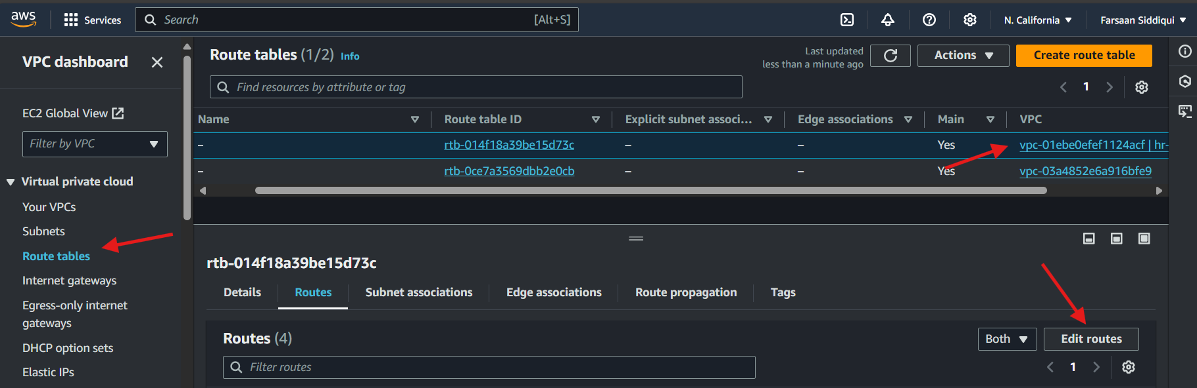

**>>ADD ALL THE CIDR RANGE IN THE ROUTE BY “ADD ROUTE” and SAVE CHANGES**

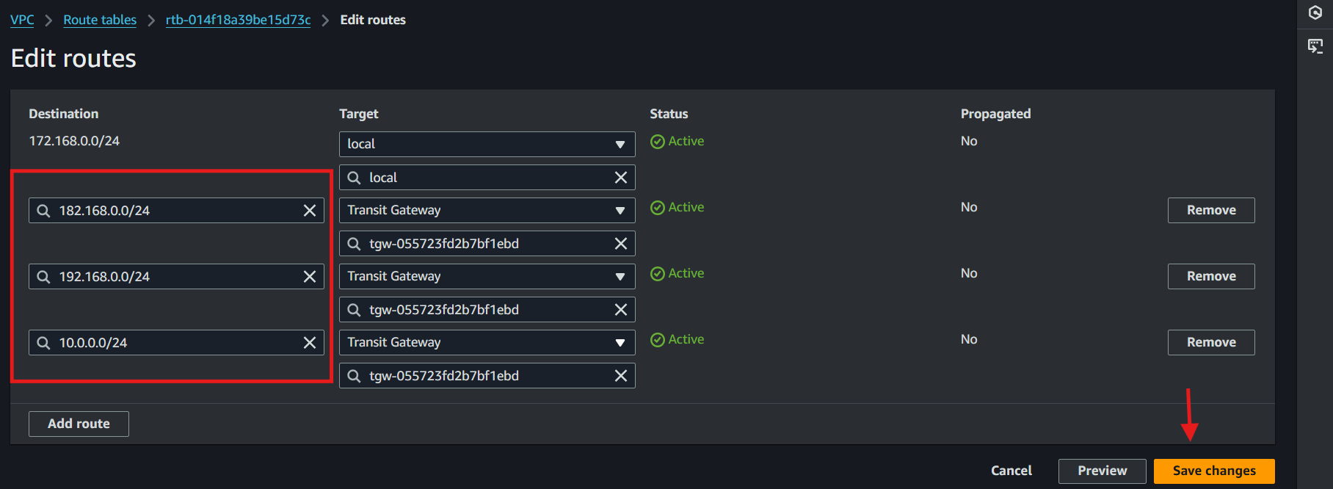

**\*NOTE: Add the Internet gateway to route table for public subnet**

CREATE 1 EC2 INSTANCE IN ALL DIFF REGIONS AND SELECT THE VPC CREATED

<make sure to create one ec2 with public subnet and rest 3 with private subnet>

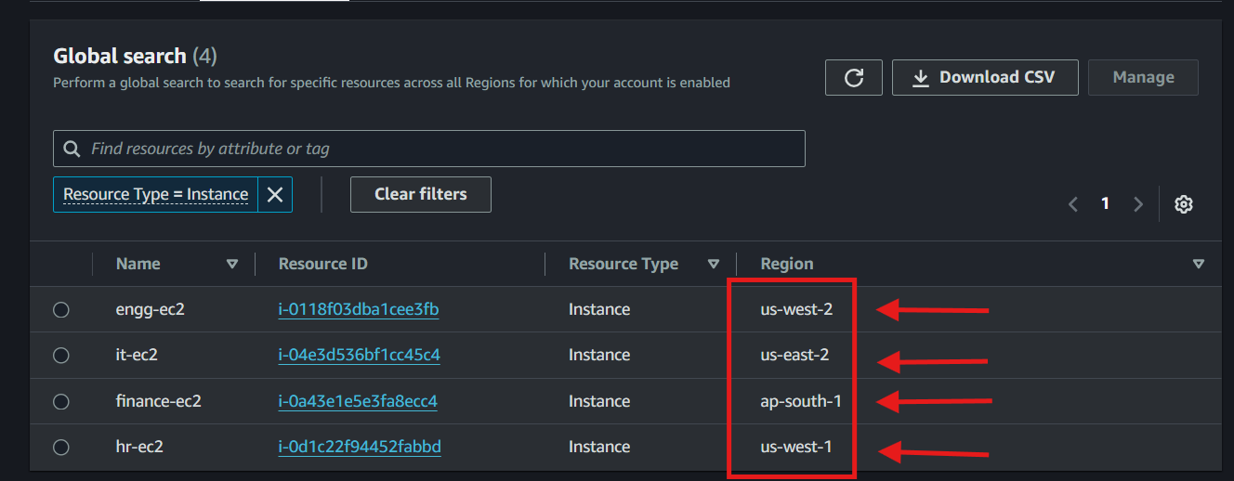

<check for security group that it has inbound rule for all traffic with 0.0.0.0/0 rule>

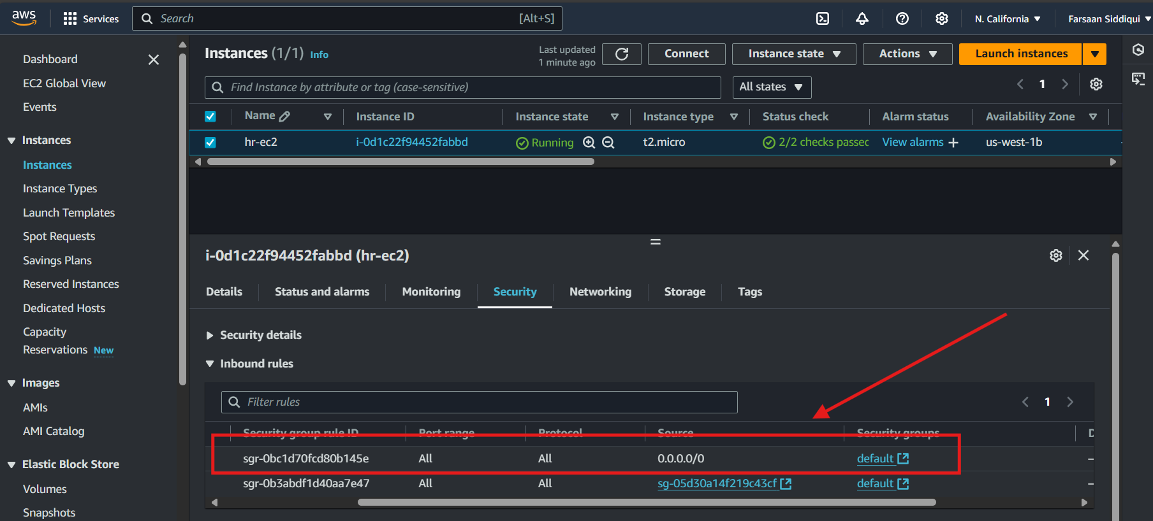

***>>NOW LOGIN THROUGH SSH WITH THE PUBLIC EC2 AND TRY TO PING ALL THREE EC2 “PRIVATE IP’s”***

